Name=anok

Batch =125

[Gmail=anokay14@gmail.com](mailto:Gmail=anokay14@gmail.com)

**Today Topic: connect s3 bucket to instance by using IAM**

**1] IAM create:**

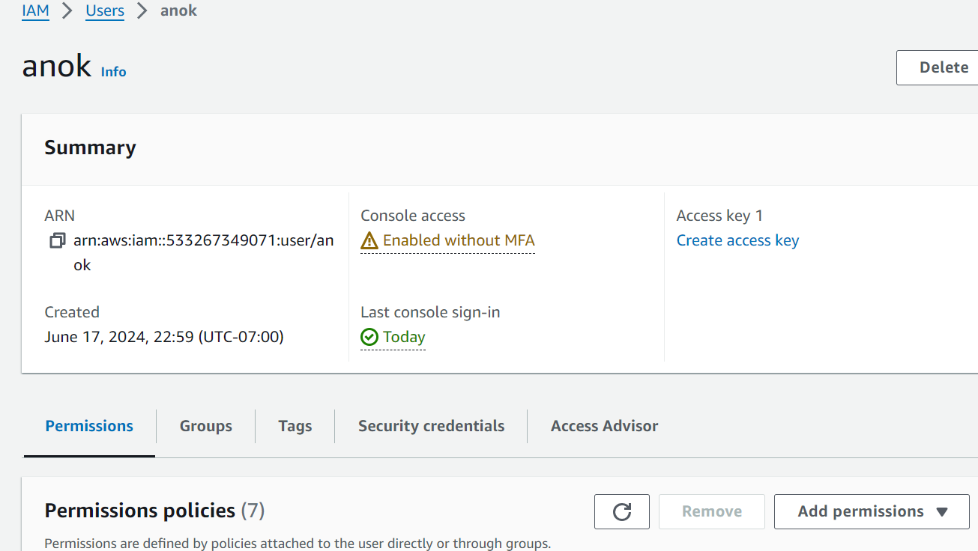

**2] Roles create:**

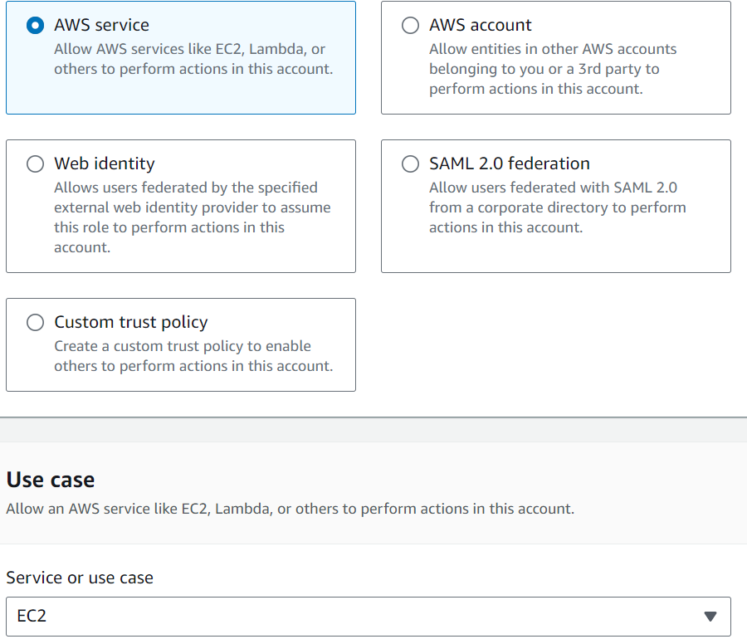

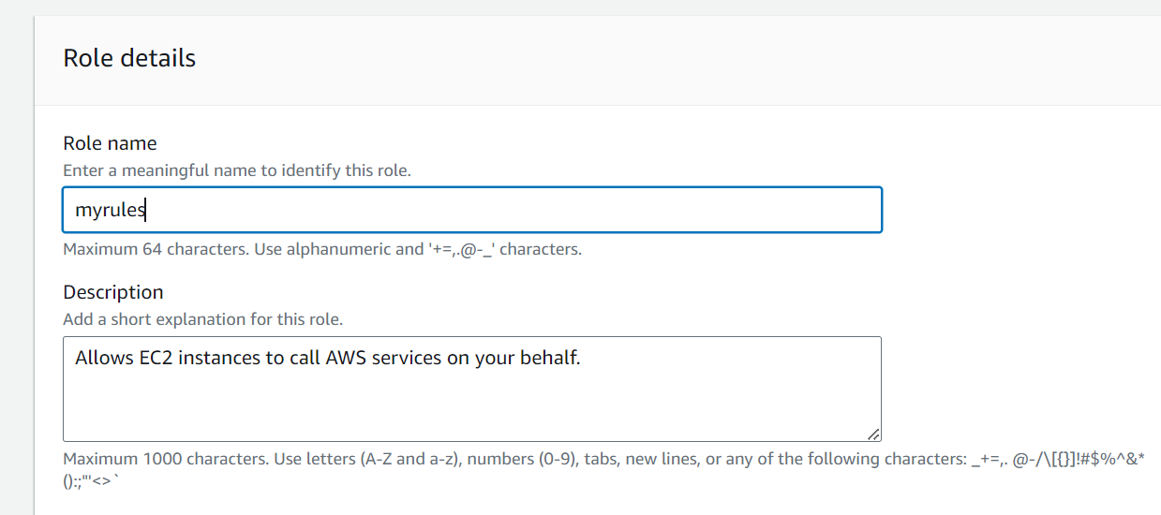

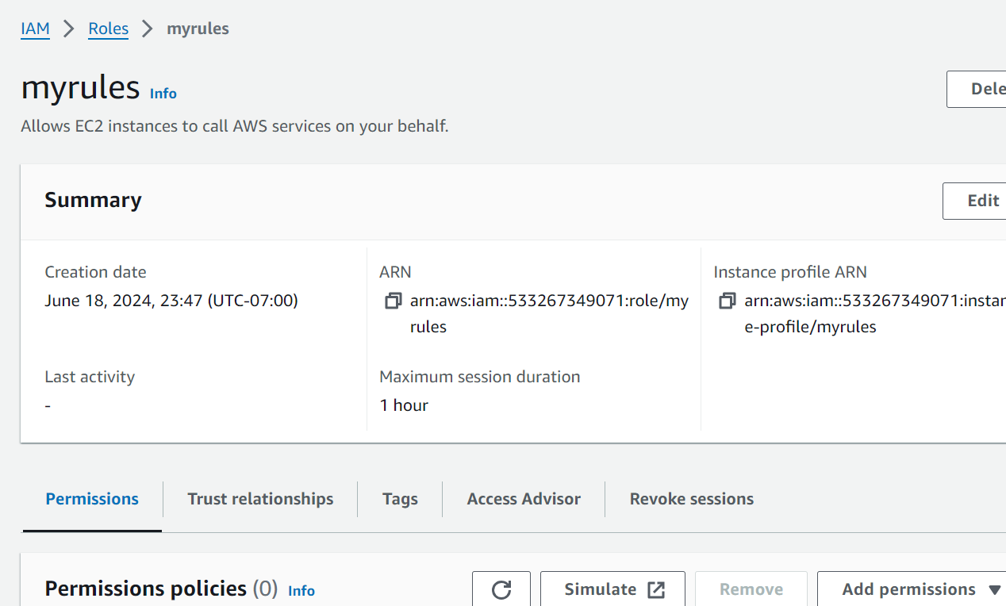

**3]Ec2 create:**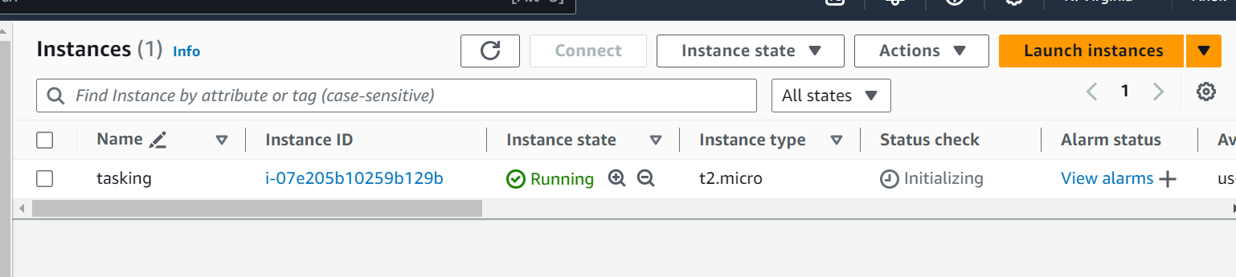

**4]Modify IAM role:**

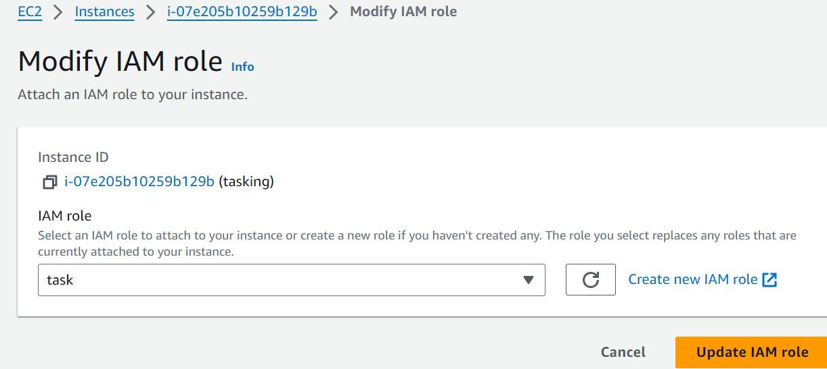

**5]S3 upload file:**

